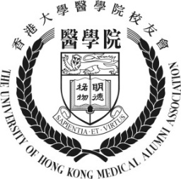

THE UNIVERSITY OF HONG KONG

Medical Alumni Association (HKUMAA)
Replacement of Membership Card Form
To: | HKUMAA Secretariat
 | c/o Medical Faculty Office
 | G/F, Faculty Administration Wing, LKS Faculty of Medicine
 | 21 Sassoon Road, Pokfulam, Hong Kong
Tel: | (852) 3917 9305 / (852) 3917 9212
Email: | hkumaa@hku.hk

Name in English | Professor / Dr / Mr / Miss / Ms / Mrs *
Name in Chinese |  |  | Gender |  | M / F *
HKID/ Passport* |  |  | Date of Birth |  | DD / MM / YYYY
Home Address
Office Address
Phone No. | (Home) | (Office) |  |  |  | (Mobile/Pager)
E-mail |  |  |  | Fax No
Degree(s) of Curriculum |  |  |  | Year of Graduation
Area(s) of Specialty
*Please delete as appropriate
Membership Card Replacement fee: HK$50
Payment Method | □ Cheque (Submit a cheque for membership fee, payable to “The University of Hong Kong Medical Alumni Association”.)
 | □ Paypal (A payment request email will be sent to the email address provided upon the receipt of your application form. Click "Pay Now" in the email and you will be directed to PayPal page to make the payment online by credit card.)

The undersigned agrees that the personal data provided above can be used by:
1. the Alumni Association for furtherance of the objectives stipulated in the Articles of Association;
2. the Alumni Association for internal communication purposes; and
3. the University of Hong Kong for communication with graduates.
Date: ____________________________________ Signature: ____________________________________
Office use only
Lost Card No.: New Card No.:
Cheque No: Transaction Date: Processed by:

