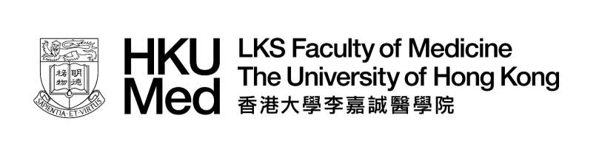

M.29/723

Master of Medical Sciences
Application for Admission as Occasional Students2023-24
(Selected Core or Specialised Courses only)

The personal data provided in this form will be used for processing your application for enrolment on the relevant courses, by
the administrative and academic departments concerned. If you wish to access or correct your personal data after submission
of this form, please contact the MMedSc Office.
An attendance certificate will only be issued to students who have attended 80% of the teaching sessions of each of their
chosen courses.
Course fee:HK$2,340per credit unit of Core Course or Specialised Course. 50% discount will be offered to full-time HKU staff, MDS/DNurs/MNurs students, and current MMedSc students taking extra courses in addition to their curriculum requirements, i.e.
HK$1,170 per credit unit.
This form should be completed and returned to the MMedSc Office, LKS Faculty of Medicine (6/F, William M.W. Mong Block, 21
Sassoon Road, Hong Kong) together with a Hong Kong dollar cheque for the course fee, which must be crossed and drawn in
favour of "The University of Hong Kong". For enquiries, please contact the MMedSc Office via Email:mmedscap@hku.hk.

PERSONAL INFORMATION

Name
Mailing Address
Email Address
Mobile Phone No.
Qualifications

For Current Taught Postgraduate Student only:
Programme
Registration Date
University No.

For Full-time HKU Staff only:
Position held
Starting date
Department/School

COURSE SELECTION

I wish to enrol in the following Core Course(s)#:(3 Credit Units of each Core Course)

☐ | MEDI6500 | Cell Metabolism (Semester 1)
☐ | PATH6100 | Laboratory Methods and Instrumentation (Semester 1)
☐ | PATH6300 | General Cytopathology (Semester 1)
☐ | PATH6500 | Practical Course in Laboratory Methods (Semester 2) [Prerequisite: PATH6100]
☐ | PATH6600 | Fundamentals of Common Human Diseases (Semester 1)
☐ | PATH6700 | Recent Advances in Cancer Biology (Semester 2)
☐ | PHAR6100 | Principles of Drug Action (Semester 1)
☐ | PAED7100 | Principles to Genetic Counselling (Semester 2) [NEW]
☐ | PHAR7300 | Therapeutic Antibodies (Semester 2)
☐ | SBMS7100 | Practical Bioinformatics (Semester 1)
☐ | SBMS7200 | Genes and Gene Functions in Diseases (Semester 2)
☐ | SBMS7500 | Advanced Cell Biology (Semester 2)
☐ | SBMS7600 | Integrative Perspectives of Body Functions (Semester 2)

#ForcoursesCMED7100 and CMED7200offered by the School of Public Health, please complete a separate application form for short courses available athttps://www.mph.sph.hku.hk/short-courses,or please contact the School of Public Health via Email:mphsph@hku.hk for details.

I wish to enrol in the following Specialised Course(s):

CourseCode(s) | CourseName(s) | Credit Units
☐ | I will attend the examination(s) for the course(s) [pass mark: 50]  Please indicate the course code(s):
☐ | I will not attend the examination(s) for the course(s).  Please indicate the course code(s):

Total Core/Specialised Course(s)
Total Credit Units
Total course fee for the selected course(s) | HK$
Bank Name
Cheque No.

Date: |  |  |  | Applicant’s Signature:

To be approved by:

The Course Coordinator of the Department/School of

☐ | I approve the application of this candidate for the study of the selected Core/Specialised Course(s).
☐ | I do not approve the application of this candidate for the study of the selected Core/Specialised Course(s).

Date: |  |  |  | Course Coordinator’s Signature:

Core Course(s)Timetable can be found at:
https://www.med.hku.hk/en/teaching-and-learning/postgraduate/tpg/mmedsc.

Please kindly contact the Departmental Coordinator(s) concerned to request the timetable for the Specialised Course(s). Contact details can be found at: http://www.med.hku.hk/images/document/03edu/taught/mmedsc/enquiries.html.

July 2023

